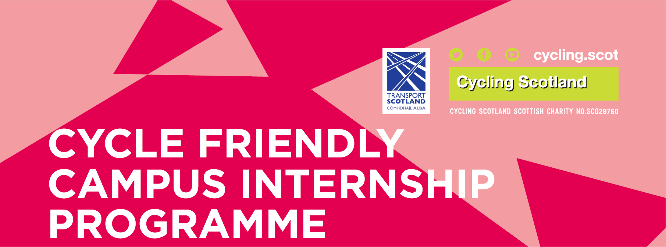

2019-20 APPLICATION FORM

APPLICATION DEADLINE: Wednesday the 15th of May 2019
- Please complete the application fully
- Applications should only be completed and submitted following consultation with a Cycling Scotland member of staff.
For further advice and to submit applications please contact
Valentin Jeanjean, Development Officer:
valentinjeanjean@cycling.scot 0141 229 5443
Background & Purpose
In partnership with Bright Green Business and with the support of Transport Scotland, Cycling Scotland seek to sponsor a number of paid internships in colleges and universities across Scotland.
Interns will take on the role of Campus Cycling Officer (CCO) delivering a range of cycling activities which are aimed at getting more students and staff travelling by bicycle.
Summary of placement terms
- Placements will run for the 2019/20 Academic Year.
- Interns will be participants in Bright Green Business’ Environmental Placement Programme (EPP) for the first 12 weeks of placement.
- Beyond 12 weeks, interns will enter into a contract of employment with Bright Green Business for the remainder of their placement.
- Interns will be paid the current Scottish Living Wage of £9.00 per hour.
- Bright Green Business will arrange interviews, organise contracts and payroll and deal with personnel activities throughout the placement
- The host organisation must nominate a member of staff to mentor the intern during the course of their placement.
- The host organisation must provide the intern with access to a workspace and IT equipment, relevant systems and corporate mailbox/email address.
- The host organisation should complete a standard staff induction (so far is as relevant), with particular emphasis on Health & Safety policy and practice.
- It is expected that the officer will develop capital funding bids for capital infrastructure funding such as Cycle Friendly Campus Development fund and/or other available infrastructure funding.
- It is expected that the host organisation will reimburse interns for any necessary (approved) business travel or reasonable expenses, to reflect policy (as it might apply to any member of staff).

Recruitment Process
- Cycling Scotland have created a specification for the role of Campus Cycling Officer as attached in Appendix A.
- This specification explains the general purpose of the role, allowing sufficient flexibility for appointed Officers to focus on specific challenges identified or targets set by the host organisation.
- Bright Green Business (with support of Cycling Scotland and other partners) will advertise opportunities for approximately six weeks on a variety of different websites and social media platforms.
- Bright Green Business will sift and match candidates according to knowledge, skills and experience.
- Bright Green Business will put forward candidates for interview, undertaken by the host university or college.
- The interview panel will have the duty to select the candidate considered to be best suited to the role and host organisation.
- It is expected that Cycling Scotland may ask to be part of the interview panel.
- It is anticipated that interns will take up post in August 2019.
- Bright Green Business will provide full details of the recruitment process, timescales and ongoing support to host organisations.

Indicative timescales
The table below presents the planned schedule of the programme. The below dates are provided on an indicative basis and subject to change.
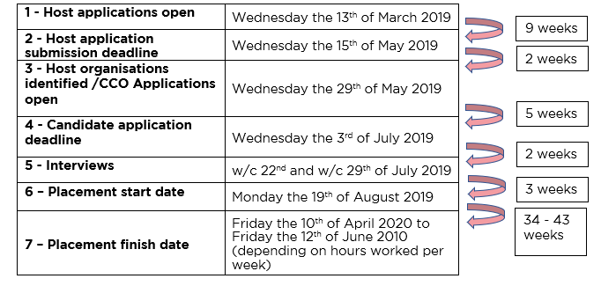

Host application process
The number of placements Cycling Scotland are able to support is limited to available funding. As such, please note that the hosts will be selected on a competitive basis. Applicants are encouraged to contact Cycling Scotland prior to submitting an application.
This application seeks to identify:
- Which institutions demonstrate most potential to increase cycling opportunities that respond to an evidenced need, for a diverse range of people, tackling socio-economic inequalities and increasing access to cycling.
- Which institutions are most likely to effectively utilise the support of an intern to increase cycling as a healthy, active and sustainable travel choice and monitor impact.
- Which institutions are most likely to best support the intern to develop skills and experience, enhancing career prospects and employability.

Please note that, where demand for funding exceeds available monies, consideration will be given to applications that seek to help tackle poverty, reduce inequality and build a fairer and more inclusive Scotland and are consistent with local, regional and national policies and strategies, such as Cycling Action Plan for Scotland, Low Carbon Strategy and the Fairer Scotland Action Plan.

Deadline: Applications should be emailed to Valentin Jeanjean at the below email address no later than 17:00, Wednesday the 15th of May 2019

For advice, please call Valentin on 0141 229 5443 or email: valentinjeanjean@cycling.scot

Application Form
Q1. Project Manager
Q2. Job Title
Q3. Email
Q4. Contact number
Q5. Institution/campus targeted
Q6. Local Authority
Q7. Number of students/Number of staff
Q8. Are you registered for the Cycle Friendly Campus Award?
(If you have already achieved the award please notify when this was)
Q9. Have you previously been involved in the Internship programme? If so, please specify academic year(s)
Q10. Please tell us how you heard about the Cycle Friendly Campus Internship programme

General Information

Please respond to each of the below questions as fully as possible.

- Please advise what staff resource is currently committed to sustainability, carbon reduction and/or active travel within your institution.

Examples: FTE, number of hours, departments, project team, volunteers.

- Please explain your institutions need for the support of a Campus Cycling Officer. Please list some of the initiatives/activities the postholder will be expected to deliver.

Examples: current lack of capacity, skills gap, growing workload, new projects and initiatives

- Please advise how the intern would be supported by your institution for the duration of their placement. Has a line manager been identified?

Examples: Mentor support, training, development opportunities / CPD

- As explained within the candidate brief, the intern will be expected to design and deliver a project. Please advise how the institution might sustain project deliverables and activity beyond the internship.

Examples: transference of responsibilities to department, societies, volunteers, alternative funding sources.

- Referring to the role description, please state any additional objectives which you plan to set for the intern.

Examples:

- Cycle infrastructure projects
- A sustainable travel plan published with help from the publishing team.
- Update the sustainable travel pages on the intranet.
- Create a programme of actions and engagement activities
- Travel emissions footprint extrapolated from travel survey data.

- Please provide any further details you feel would support your application to host a Cycling Scotland sponsored intern

Examples: Features of your institution and/or information on demographic profile of students that widens access to cycling in line with Cycling Scotland’s vision of a sustainable, inclusive and healthy Scotland where anyone, anywhere, can enjoy all the benefits of cycling.

- Please note preference for hosting intern on full-time or part-time basis (please tick).

Full Time:

Part Time:

No Preference:

- Please note if you would be willing to share an intern with another College / University.

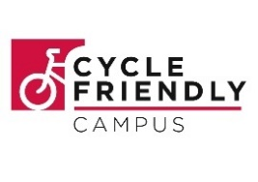
Appendix a.
Role description

campus cycling officer (CCO)
Institution | various
Campus Location(s) | tbc
Date Posted | July 2019
salary | £9 per hour (scottish Real living wage)
Placement Length | TBC (aug ’19 – Jun ’20)

Background
Cycling Scotland’s vision is a sustainable, inclusive and healthy Scotland where anyone, anywhere can enjoy all the benefits of cycling. Cycling Scotland is a recognised Scottish Charity SCO29760.
Cycling Scotland work with a range of partners towards the aims of the Cycling Action Plan for Scotland (CAPS) which carries the shared vision of ‘10% of all journeys, by bike, by 2020’
The Cycle Friendly Campus Award is aimed at encouraging and supporting colleges and universities across Scotland to take a leading role in increasing the number of students and staff traveling by bike.

The role
Working in partnership with Bright Green Business with the support of Transport Scotland, Cycling Scotland seek to identify interns to support campus-based cycling development projects across Further and Higher Education campuses across Scotland.
The candidate will take on the role of Campus Cycling Officer (CCO) and support the Sustainability, Health & Wellbeing , Estates team and/or the Students Association (or other relevant department) in delivering cycling projects and activities aimed at getting staff and students travelling by bicycle.
With support from a mentor, the CCO will be put in charge of a small budget and tasked with the responsibility of designing, planning, implementing and evaluating a cycling project.

key duties

- Support the preparation, development and delivery of cycling initiatives on campus in order to support behaviour change and progress towards/maintain Cycle Friendly status,
- Gather and analyse data relating to cycling activity, in order to prepare and present relevant information and recommendations to colleagues, stakeholders and sponsors
- Undertake a gap analysis of cycling provision on campus and verify key priorities by engaging with staff and students
- Develop and maintain effective partnerships which support the college’s efforts to make cycling an attractive travel choice, linking in with wider programmes, initiatives and events
- It is expected that the officer will develop capital funding bids for capital infrastructure funding such as Cycle Friendly Campus Development fund and/or other available infrastructure funding.
- Establish and/or develop and maintain appropriate communication channel(s) relevant to cycling development projects
- Lead on the design, planning, implementation and evaluation of a cycling project(s) and activities which reflect key priorities and feedback from stakeholder engagement
- Assist colleagues to develop and maintain an up to date Cycling Action Plan which will form the basis of future funding bids / opportunities and delivery of cycling initiatives.
- Identify and assist in applying to/securing funding when and where appropriate.

the candidate
We are looking for an enthusiastic individual who is committed to promoting the benefits of cycling as a healthy, sustainable and affordable travel option.
Experience of organising and running events would be an advantage whilst good communication skills, initiative and the ability to engage with varied audiences is essential.
This is an excellent development opportunity and we are keen to receive applications from students seeking a career in environmental sustainability, health and/or transport.
Applications are open to graduates as well as individuals with HNC/HND qualifications and those with equivalent knowledge and experience.

skills and experience
Essential | Desirable
An enthusiasm for and appreciation of the benefits of cycling | Knowledge of active travel, environmental, health and sustainability programmes and initiatives in Scotland
Strong written and verbal communication skills | Experience of workshop and event planning and delivery
Strong presentation and report writing skills | Experience of creating action plans and developing strategies
Ability to motivate and influence others | Experience of engaging and managing stakeholders
Able to manage own workload and contribute to team objectives | Understanding of managing projects and budgets

